**Linux常用命令及问题收集**

# Permission denied 权限问题



chmod 777 startClientService.sh

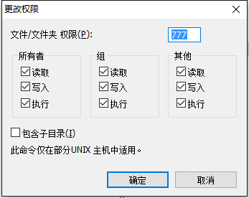

chmod -R 777 104

对某个文件夹及子文件夹设置可执行权限

# 修改格式 set ff=unix



1. 不能去除#!/bin/bash，#!/bin/sh 等
2. 利用 vi filename   
   然后用命令 :set ff?   
   可以看到dos或unix的字样. 如果的确是dos格式的, 那么你可以用set ff=unix把它强制为unix格式的，
3. 然后存盘退出. 再运行一遍看.



文件格式不对

# 磁盘命令

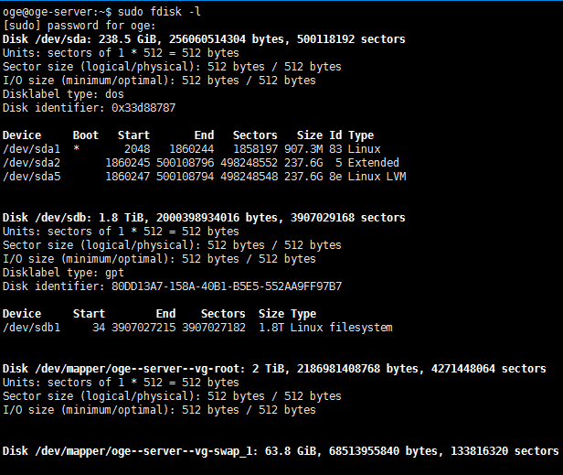

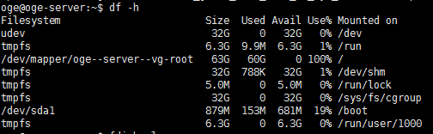

挂载后

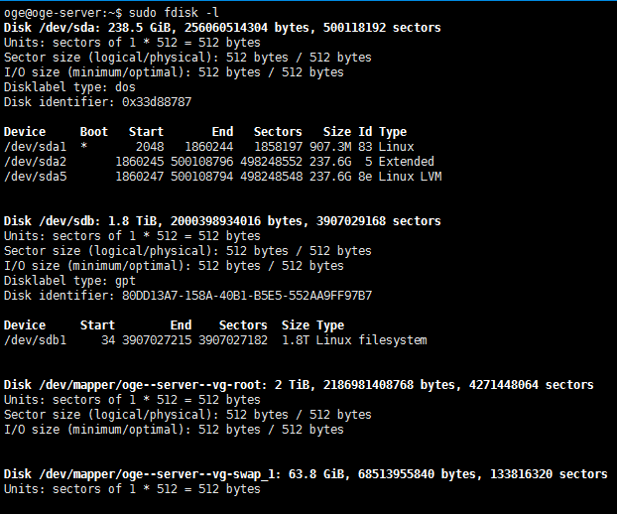

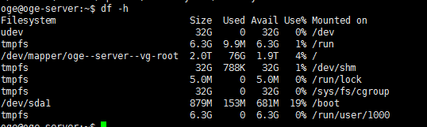

sudo resize2fs -f /dev/mapper/oge--server--vg-root

sudo e2fsck -f /dev/mapper/oge--server--vg-root

df-l

df-h

# 网络相关

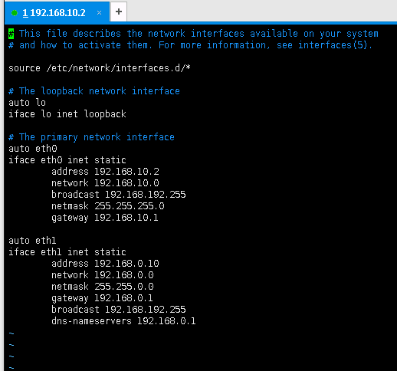

# This file describes the network interfaces available on your system

# and how to activate them. For more information, see interfaces(5).

source /etc/network/interfaces.d/*

# The loopback network interface

auto lo enp7s0 enp8s0

iface lo inet loopback

iface enp7s0 inet static

address 10.75.20.181

netmask 255.255.255.0

broadcast 192.168.192.255

network 10.75.20.0

gateway 10.75.20.1

dns-nameservers 10.2.255.168 10.1.128.10

iface enp8s0 inet static

address 198.121.0.10

netmask 255.255.0.0

broadcast 192.168.192.255

network 198.121.0.0

# Templates:

##########################

# Dynamic

# auto eth0

# iface eth0 inet dhcp

# Static

# auto eth0

# iface eth0 inet static

# address 192.168.192.168

# netmask 255.255.255.0

# gateway 192.168.192.1

sudo vi /etc/network/interfaces

sudo /etc/init.d/networking restart

# 温度监控lm-sensors

在线安装：

sudo apt-get install lm-sensors

sudo sensors-detect

sudo sensors

离线安装：



<https://www.ubuntuupdates.org/package/core/precise/universe/base/lm-sensors>

lm-sensors 需要依赖libsensors4

dpkg -i *.deb